**Counting Techniques**

**Order does matter

1234≠4321

**Permutation:**

The number of ways of arranging a set of objects

*e.g*. A B C D

Total =4x3x2x1

=24

=4!

P=Permutation

r=places

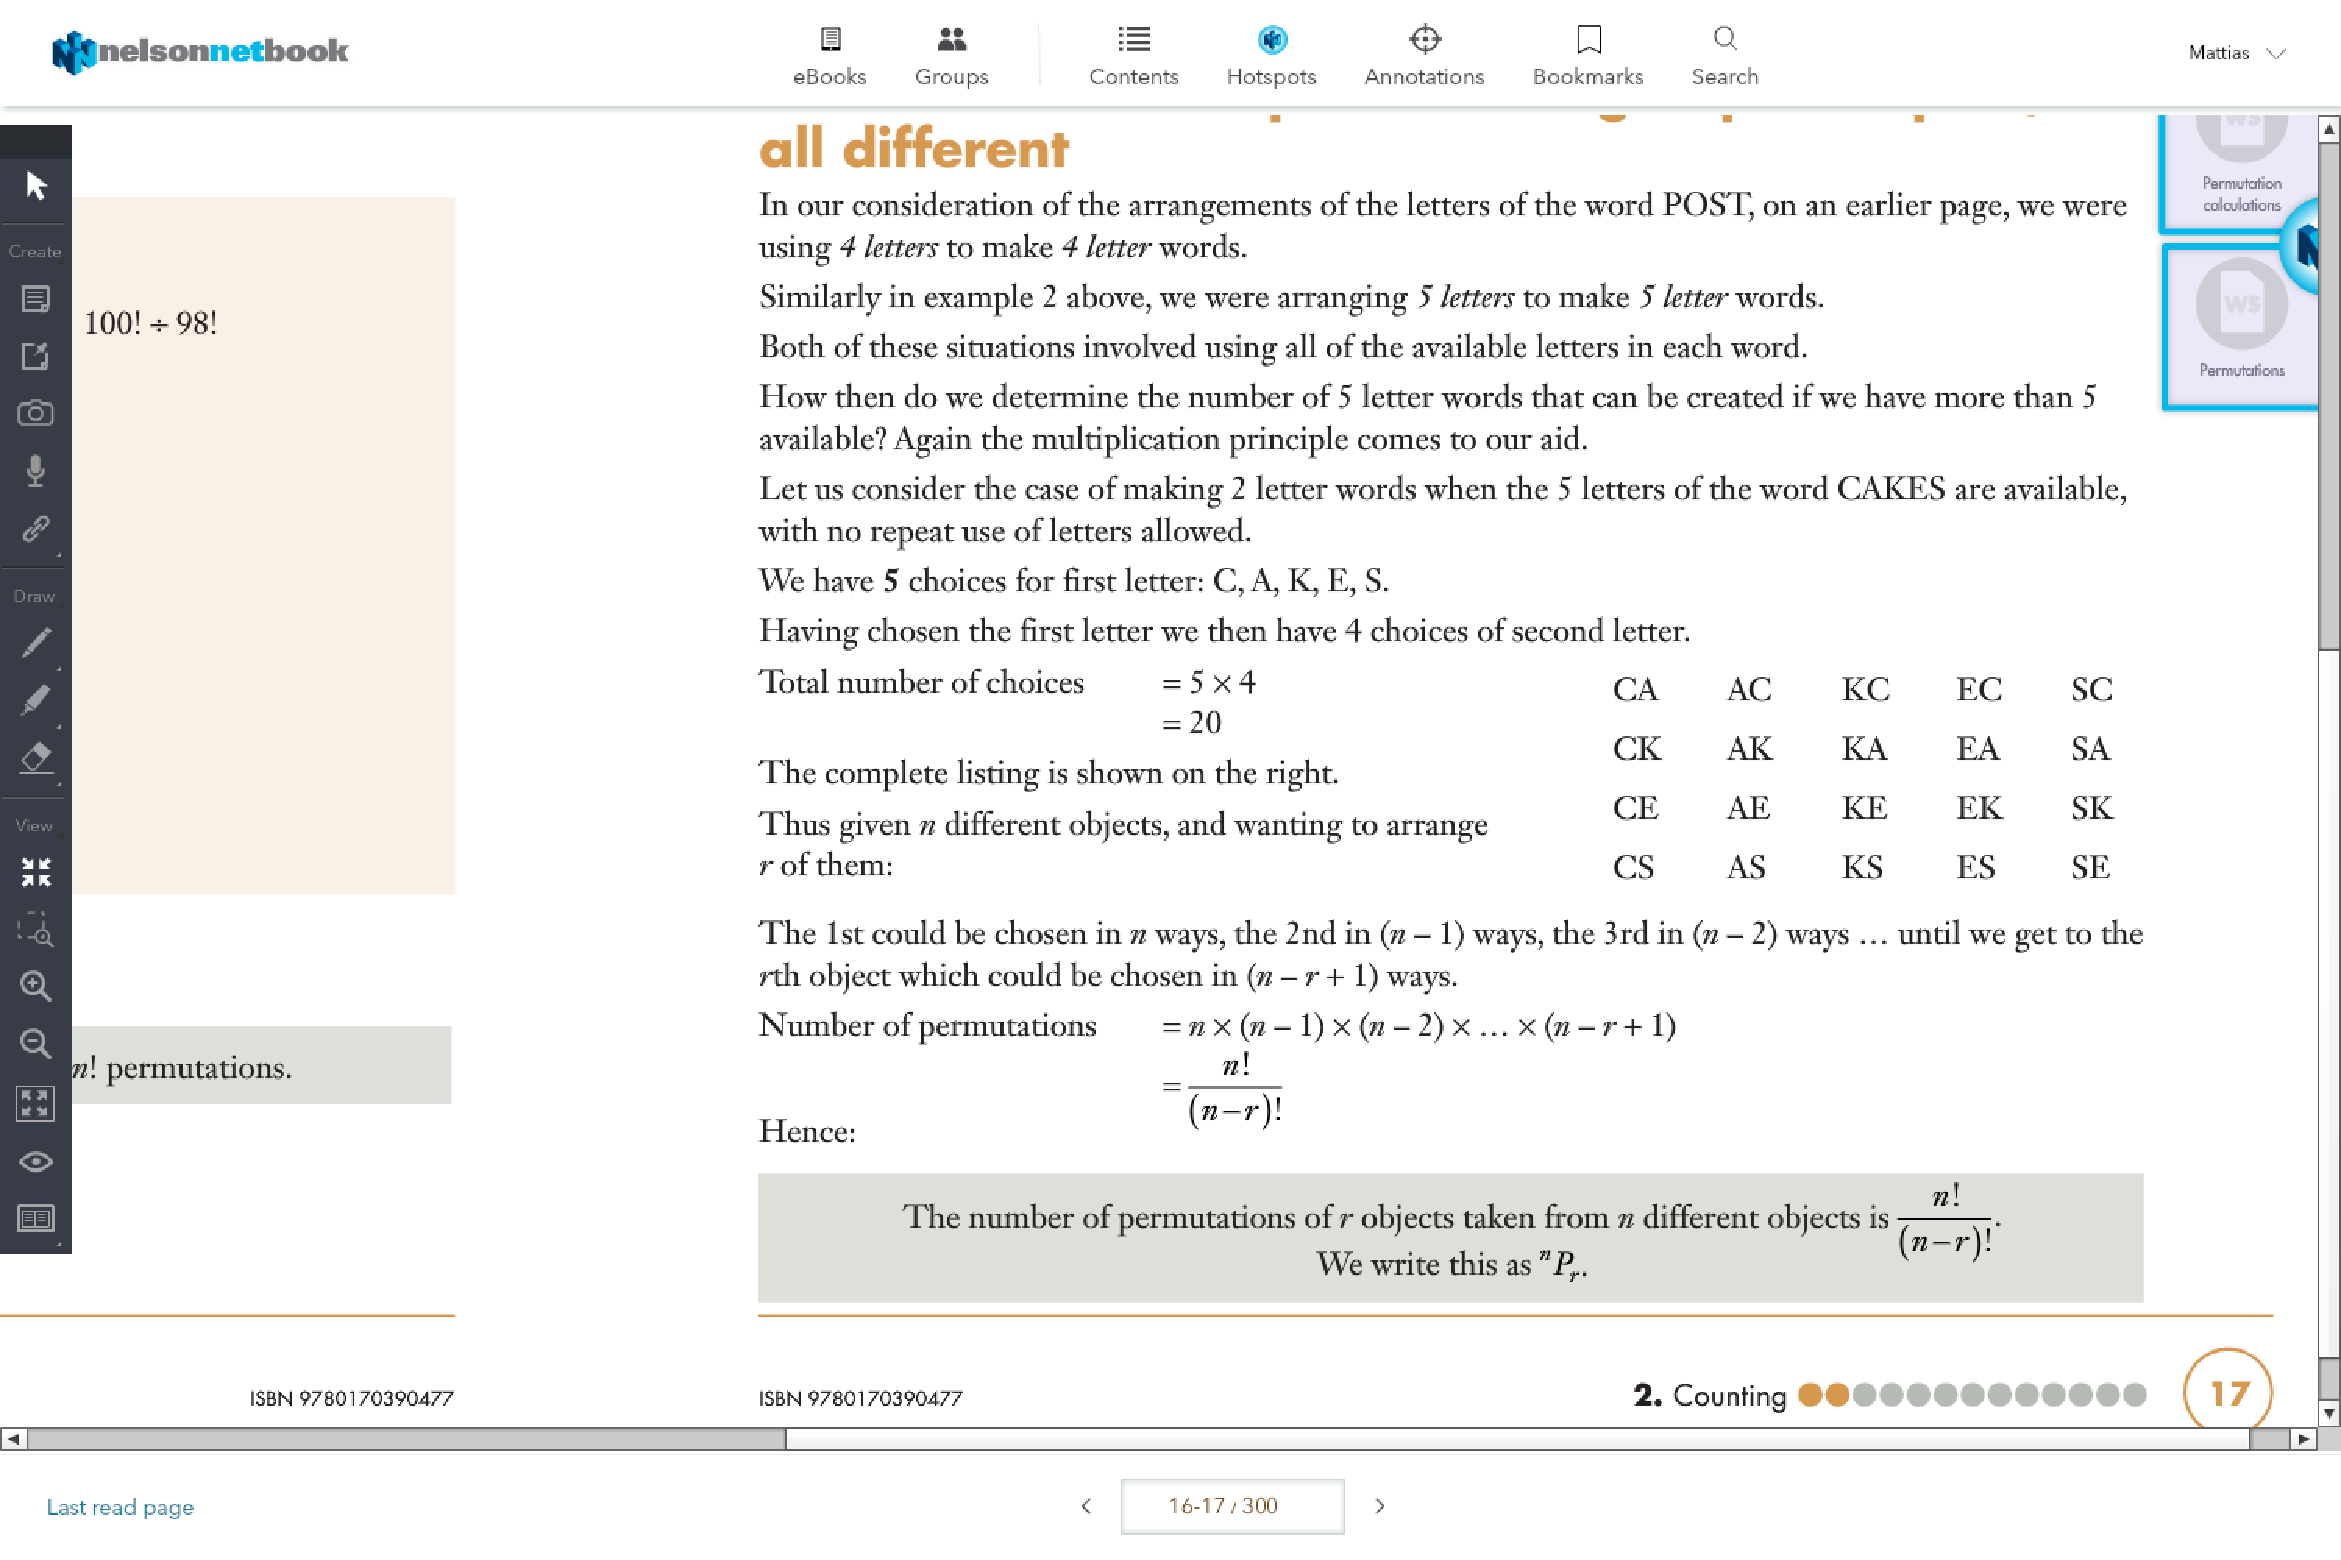

e.g. Any 4 letter permutation

26 25 24 23

=

🡪

26x25x24x23x22x21x20x19…

22x21x20x19x18x17x16x15…c

P= Does not allow repetition

e.g. Bike Lock (allows to repeat number)

10P­4 = X Does not work

10 10 10 10

104= 10,000

**Permutations of Objects, not all Different:**

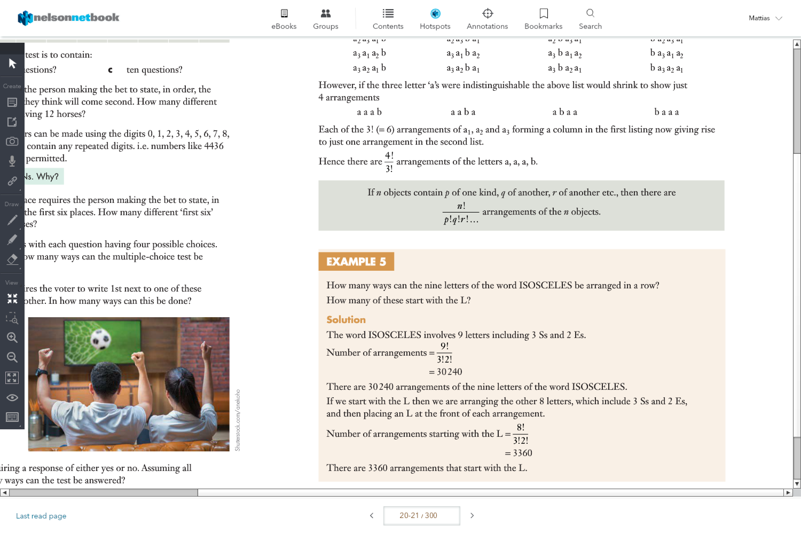

e.g.

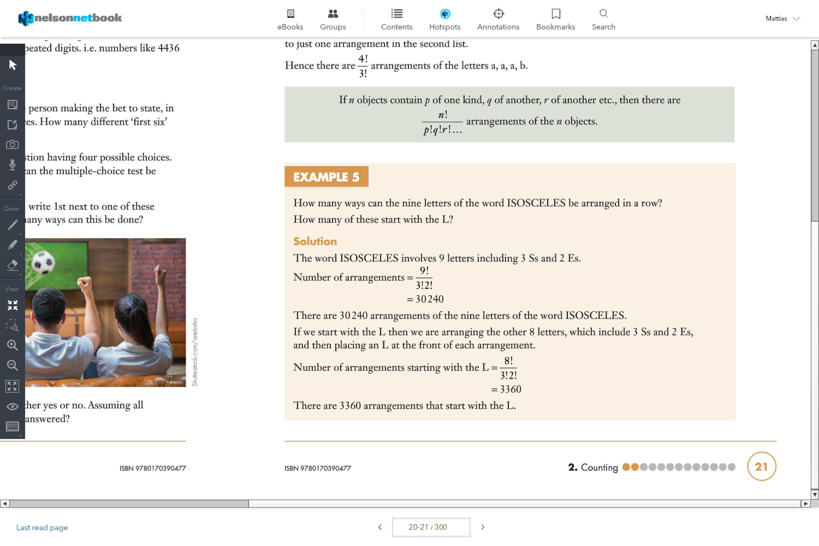

**Addition Principle**:

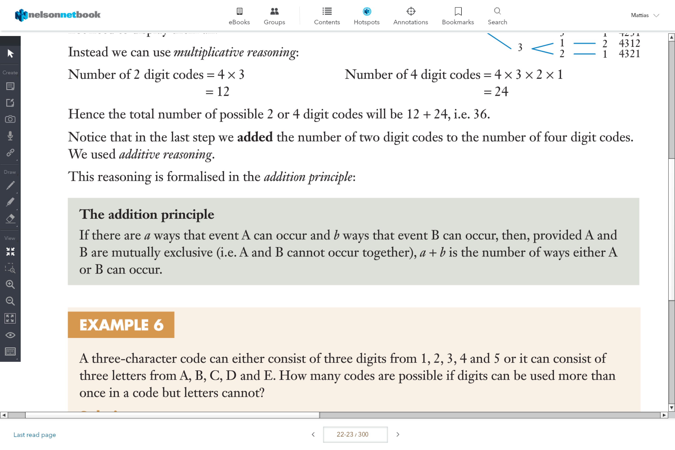

e.g.

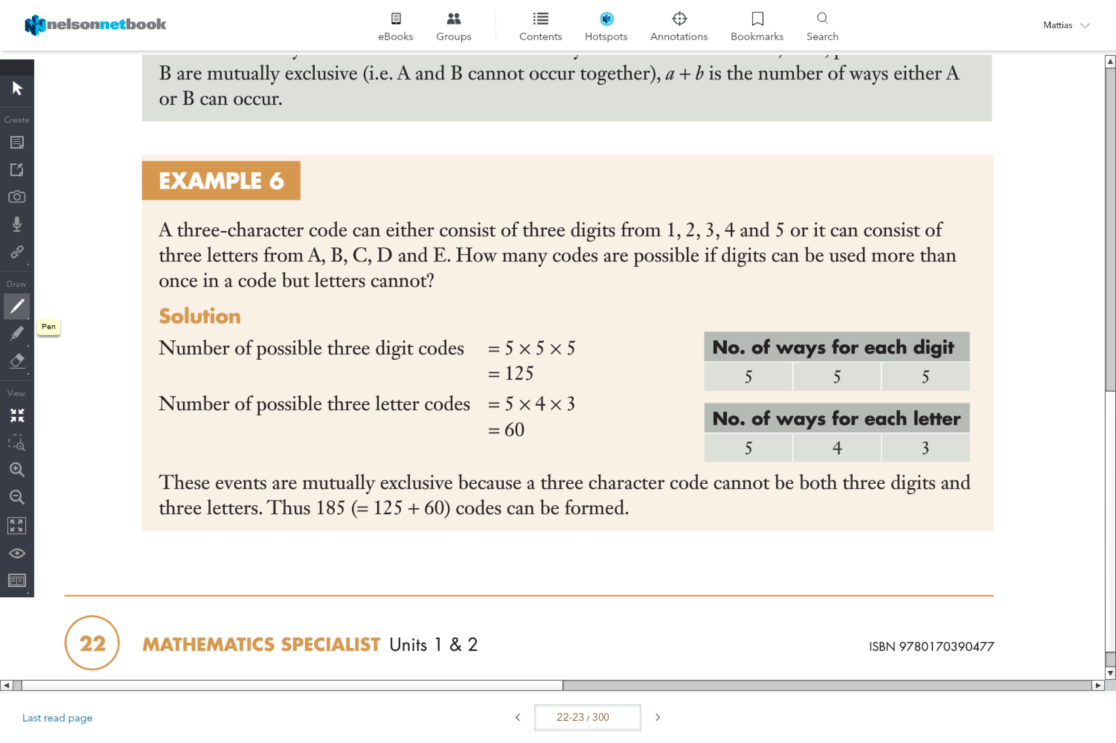

U= union

∩= Intersection

**Inclusion- Exclusion Principle:**

Is when we include the numbers of the first set, exclude the numbers of the two set intersection, then include the numbers of the 3 set intersection

<https://www.youtube.com/watch?v=szUTQRJU76Q&index=27&list=FLmBm2NbG4Ovc8ep4wASKaFg&t=0s>

-use this for when there are sets that are non-mutually and interlay

- we can either use the easier way, of drawing a ven diagram or we could also use the formula

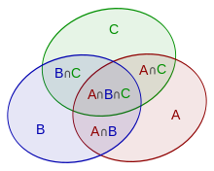

|A|, | | means the elements of A

Don’t forget to subtract the 2 intersects from A∩B∩C

And there also might be some that are neither A, B or C

But there are also formulas

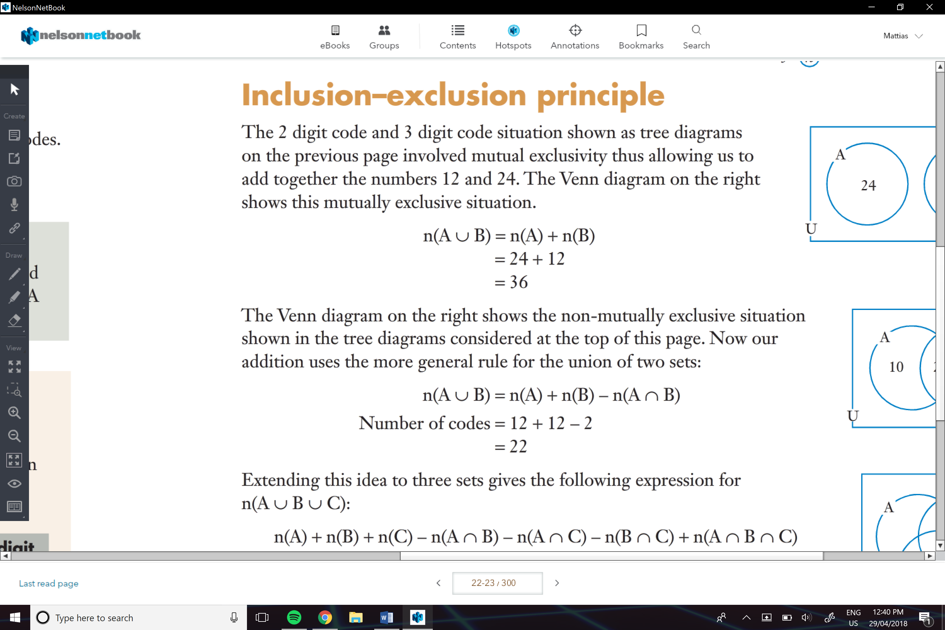

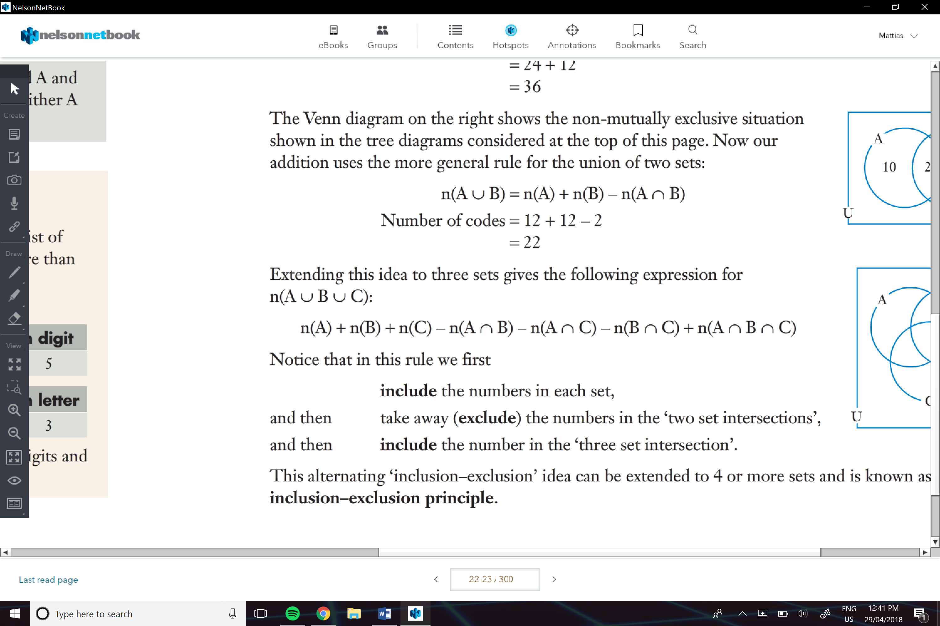

e.g.

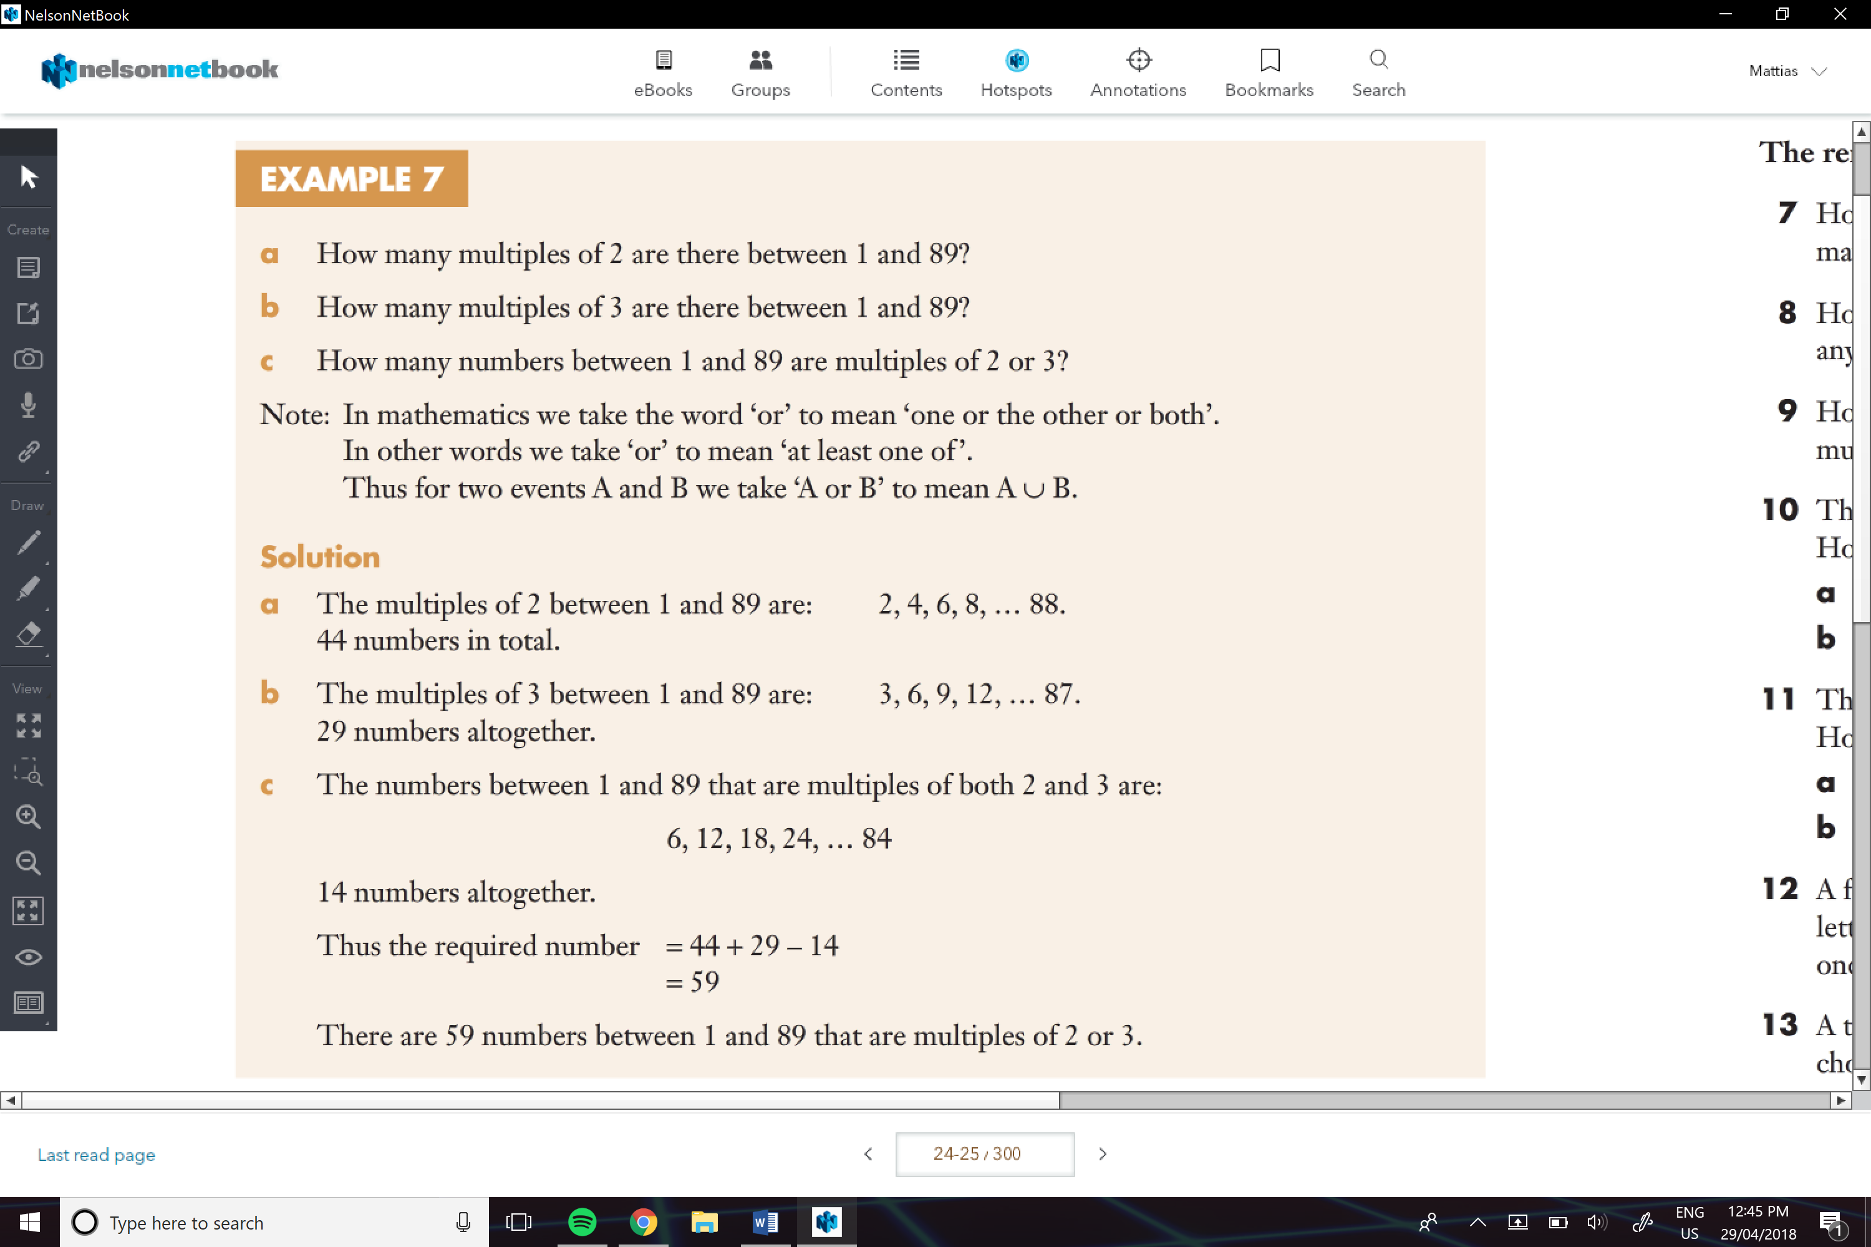

**Arrangements of Objects with Some Restrictions Imposed:**

This is for when there are certain restrictions where certain things (e.g. numbers or letter) can be.

* The best way of thinking about is that there are n-1 options and n-1 places if a object has to go in a specific place
* And if two objects have to be together then u count them as just one, but also remember that there are n numbers of places that they could be.

e.g.

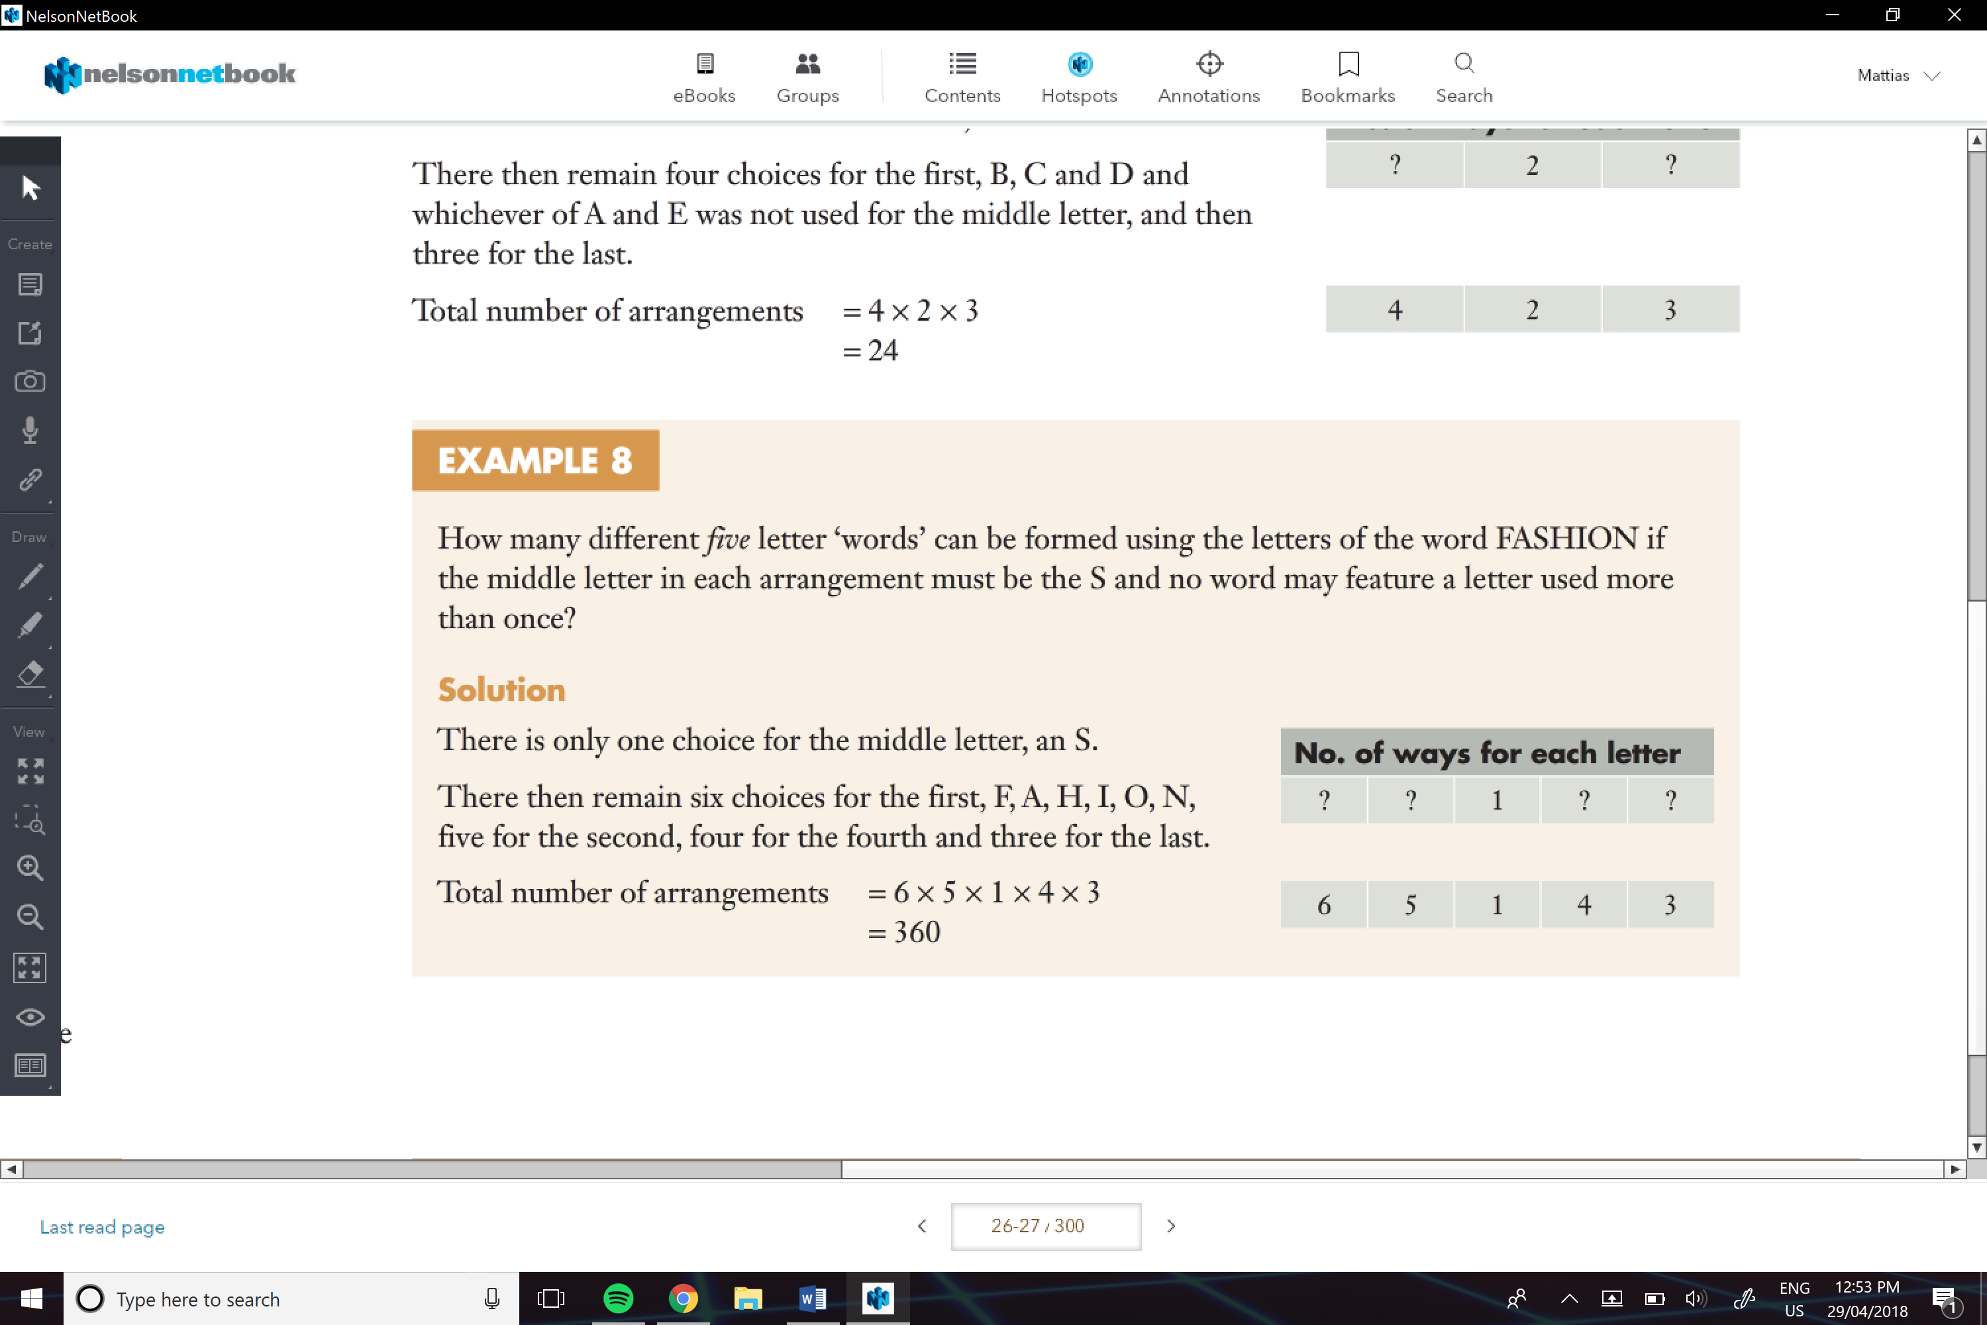

e.g.

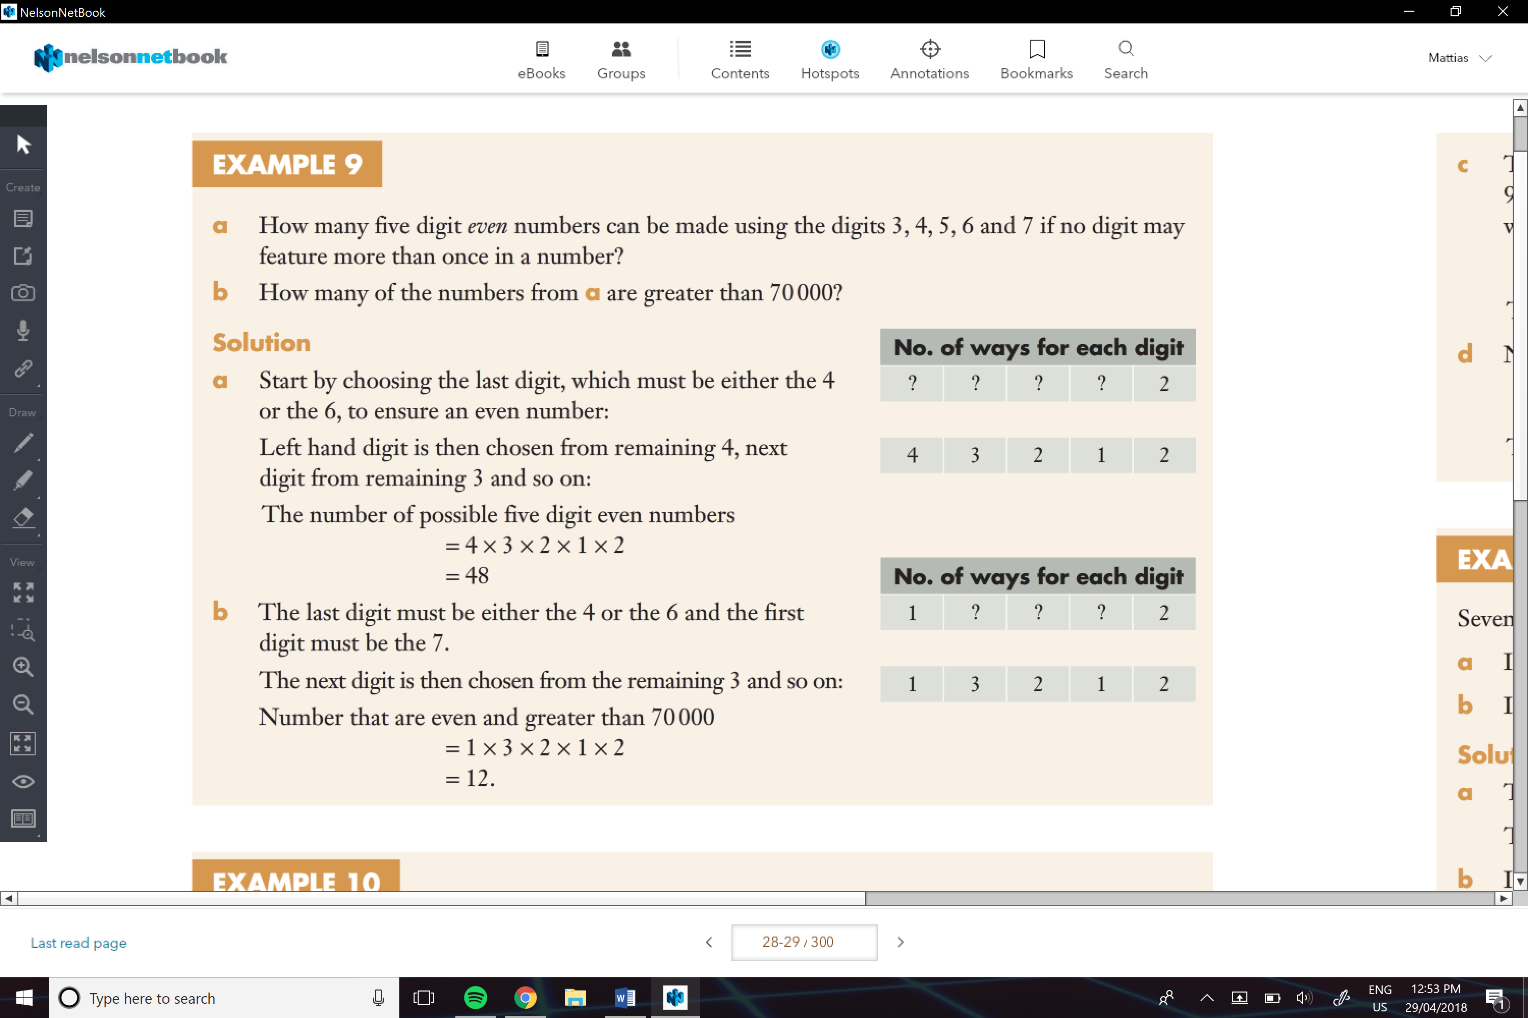

e.g.

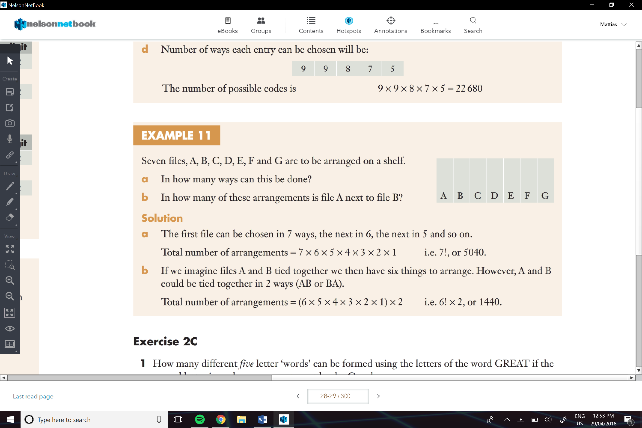

**Additive and Multiplicative Reasoning:**

You add how many times A can happen but not B and B can happen and not A and How many both can happen

e.g.

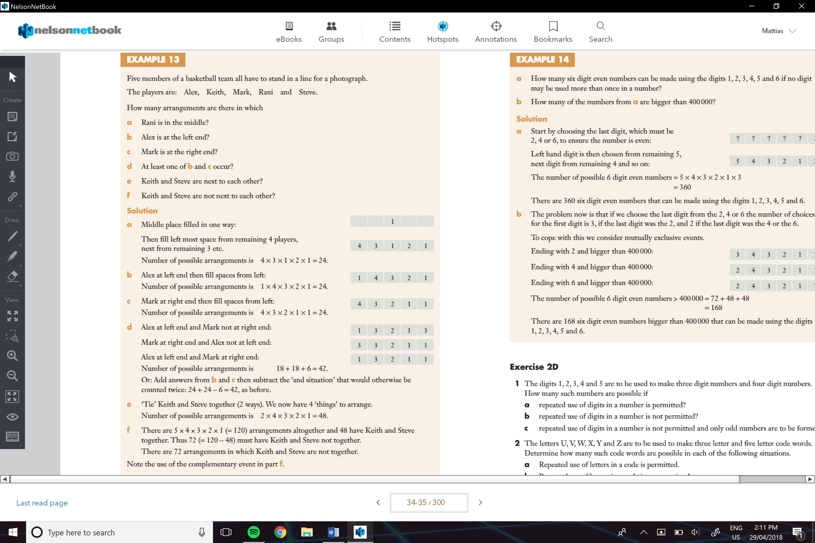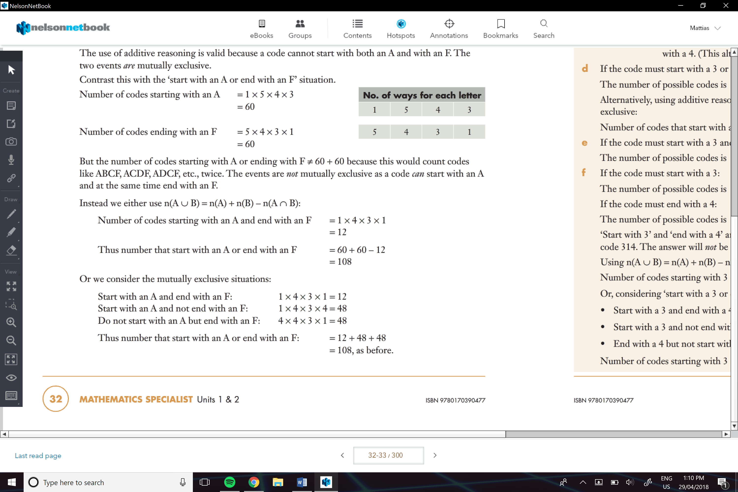 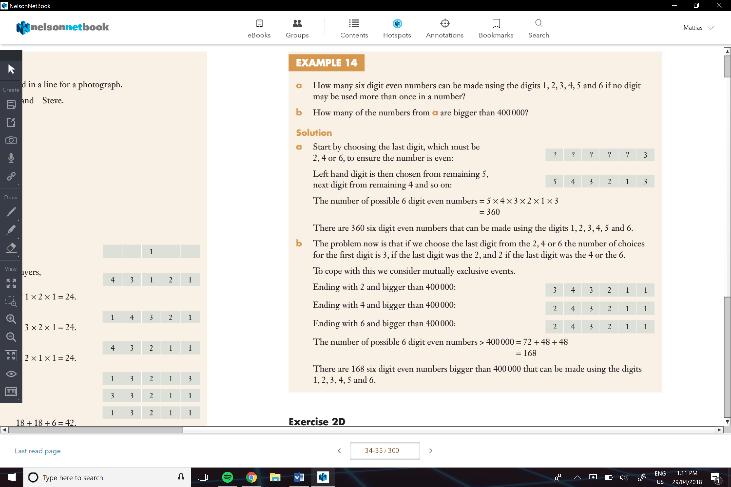

e.g.

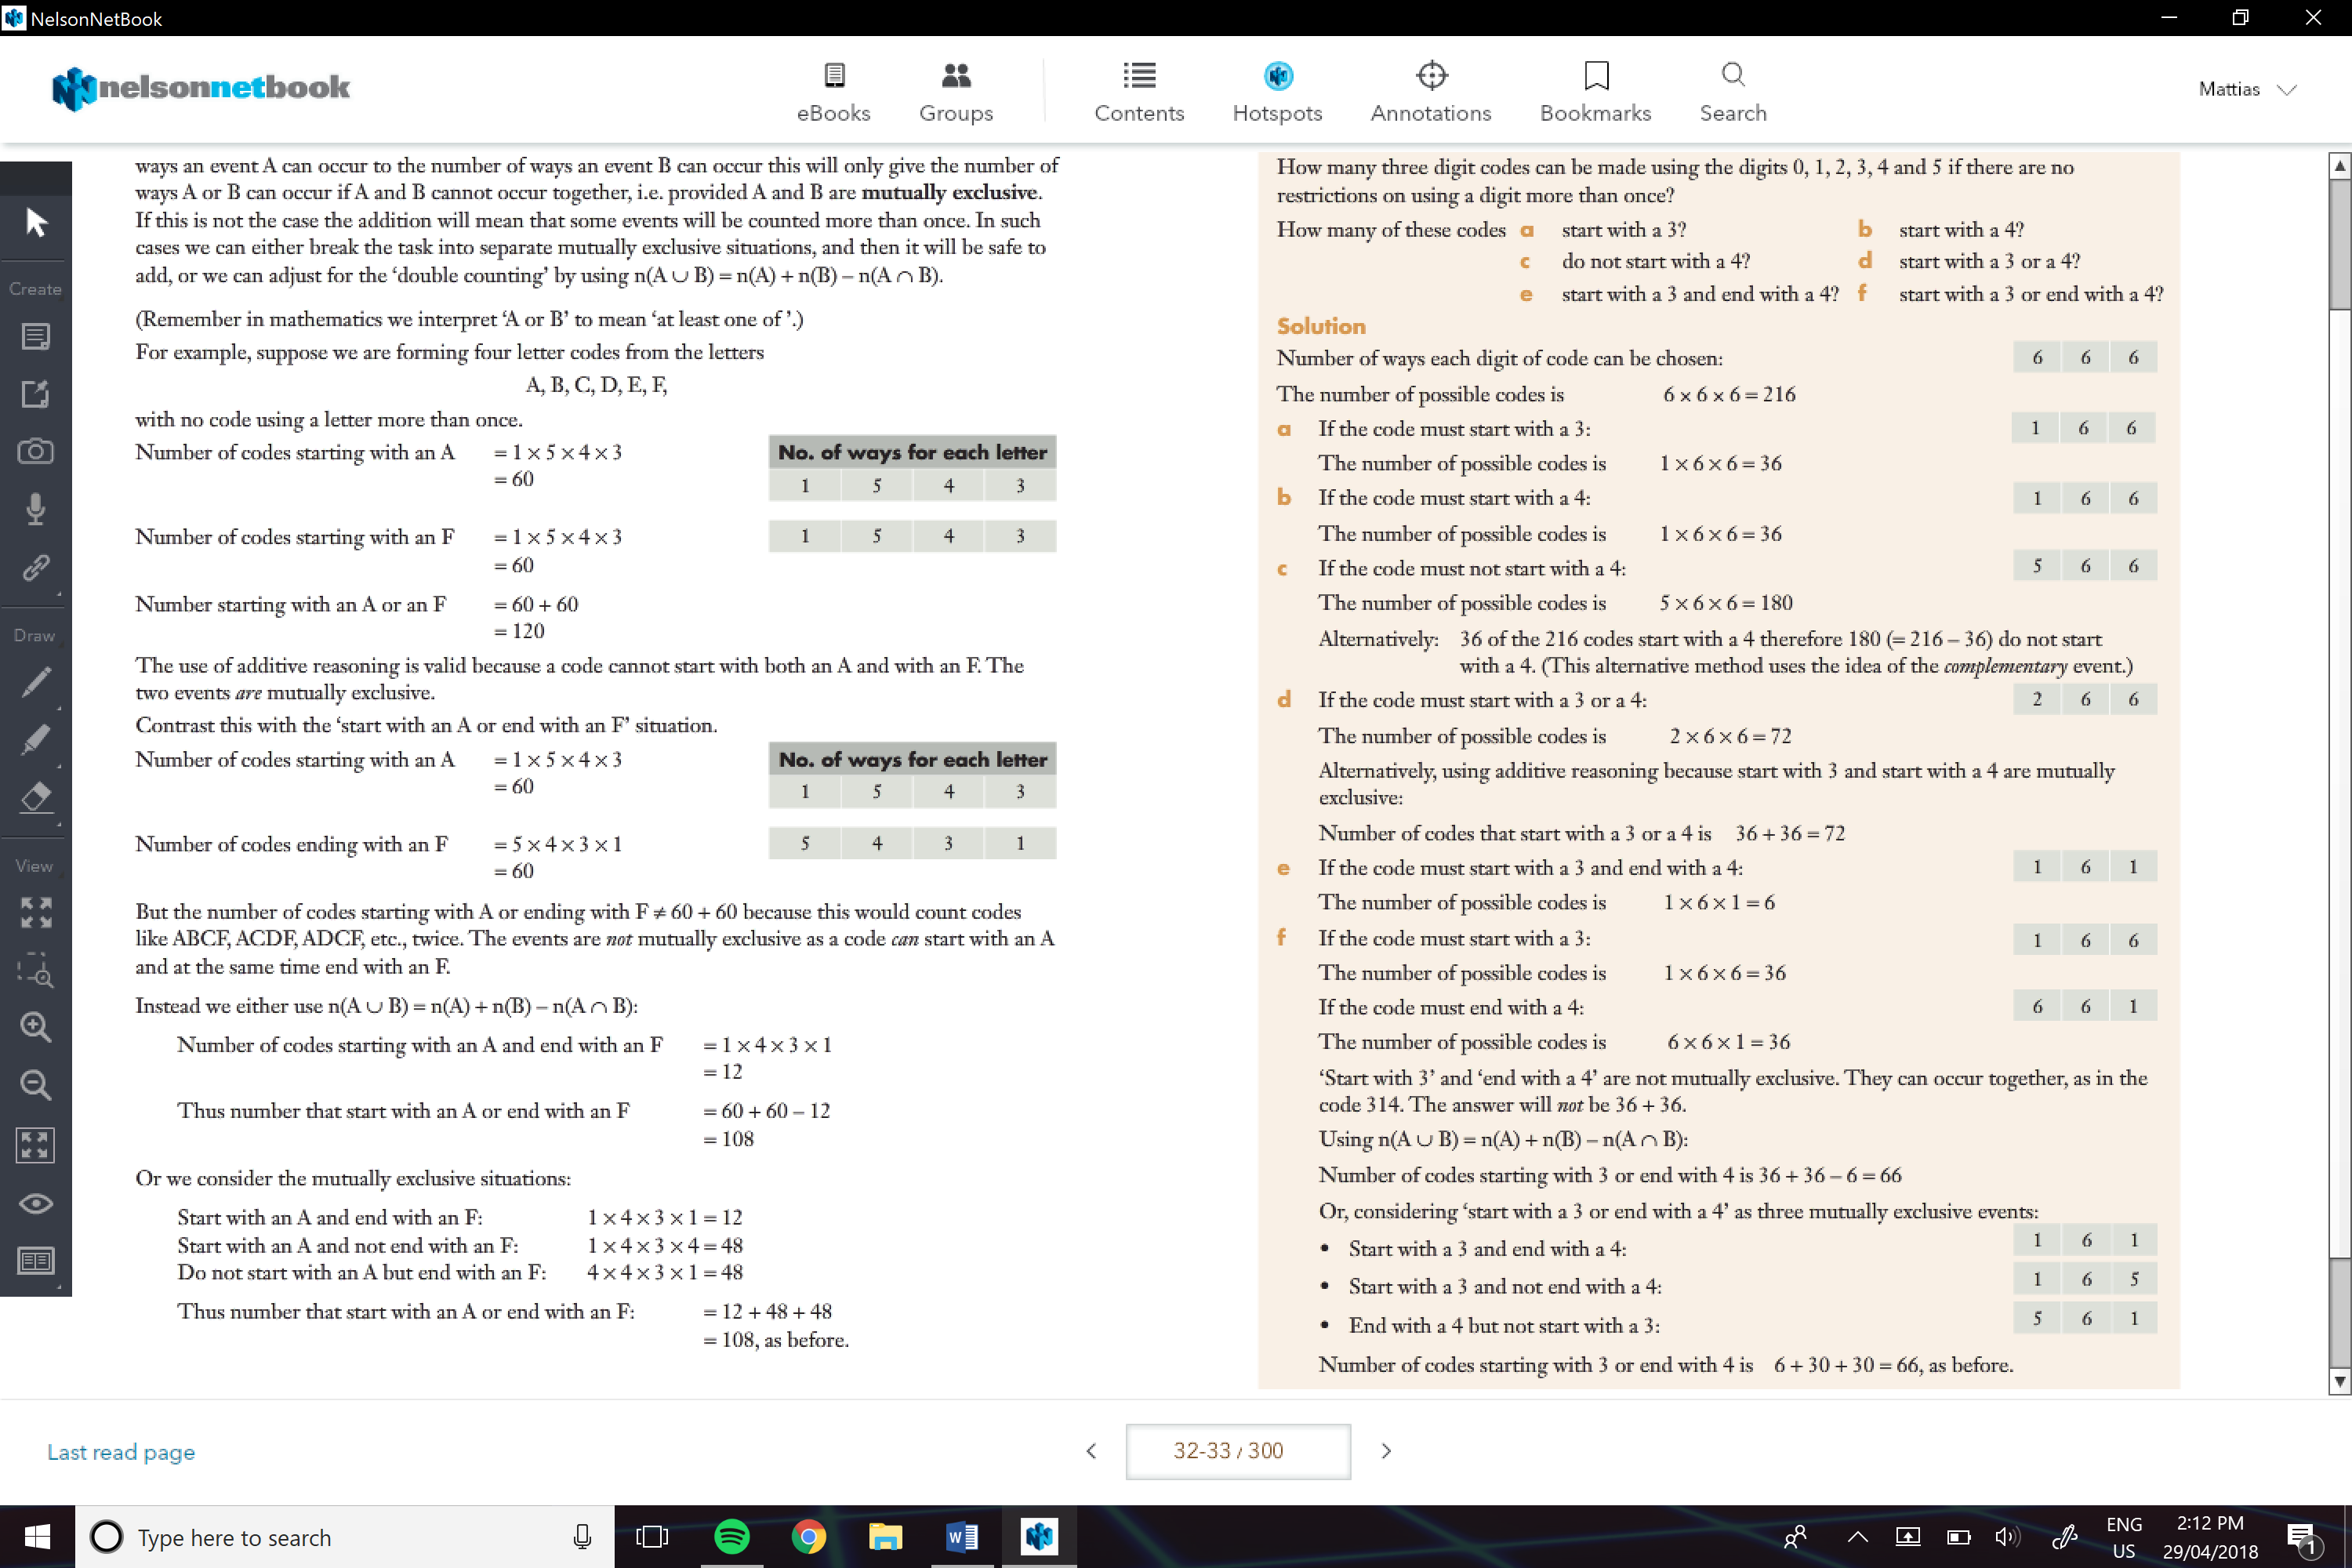

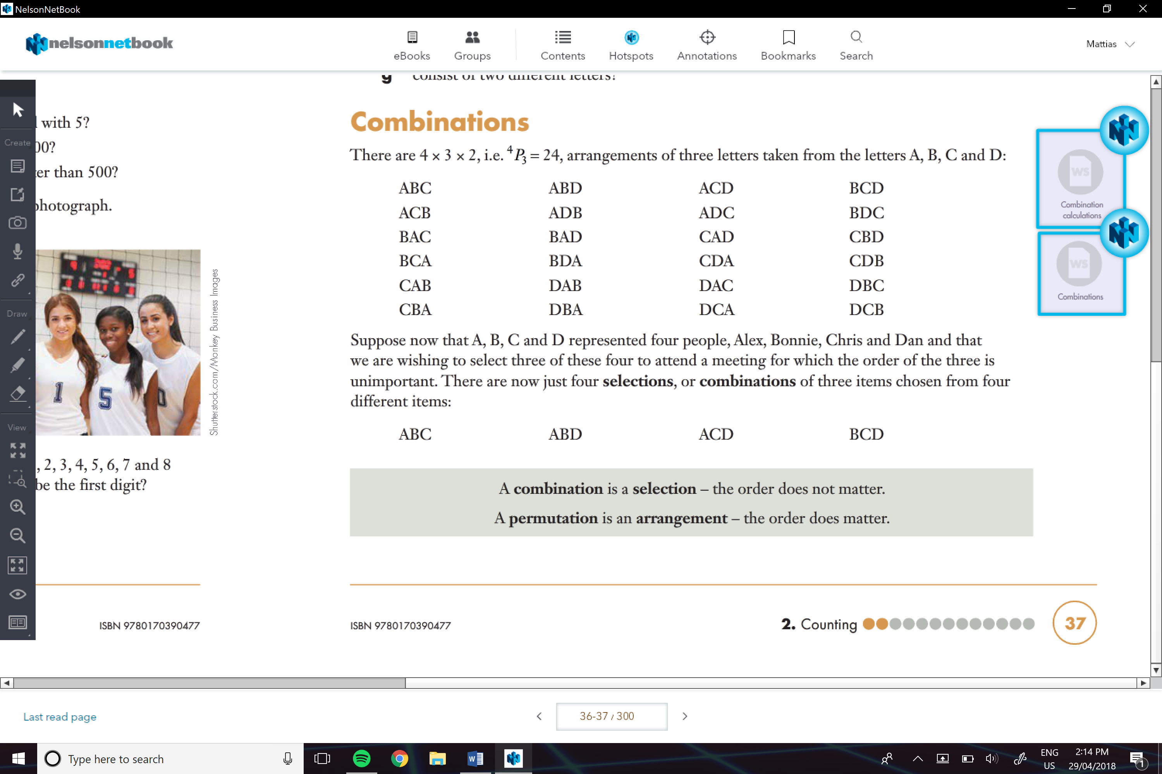

**Combinations:**

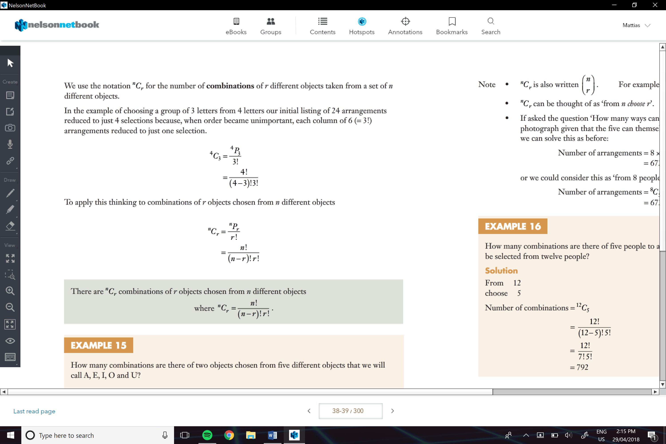

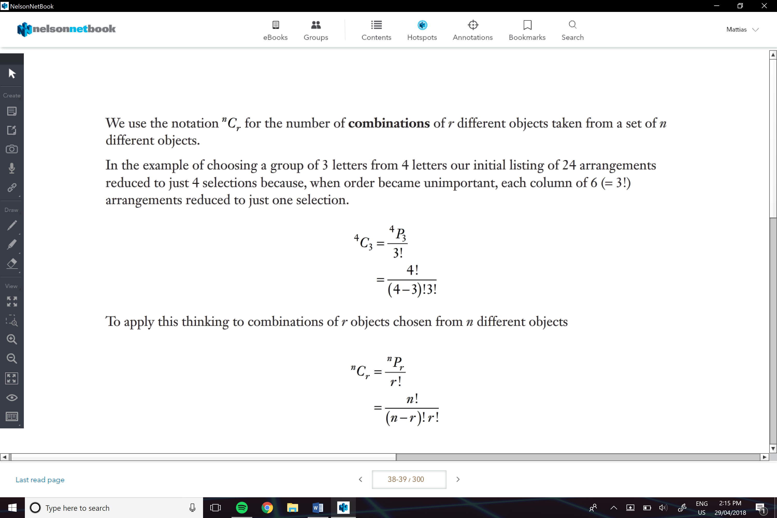

e.g.

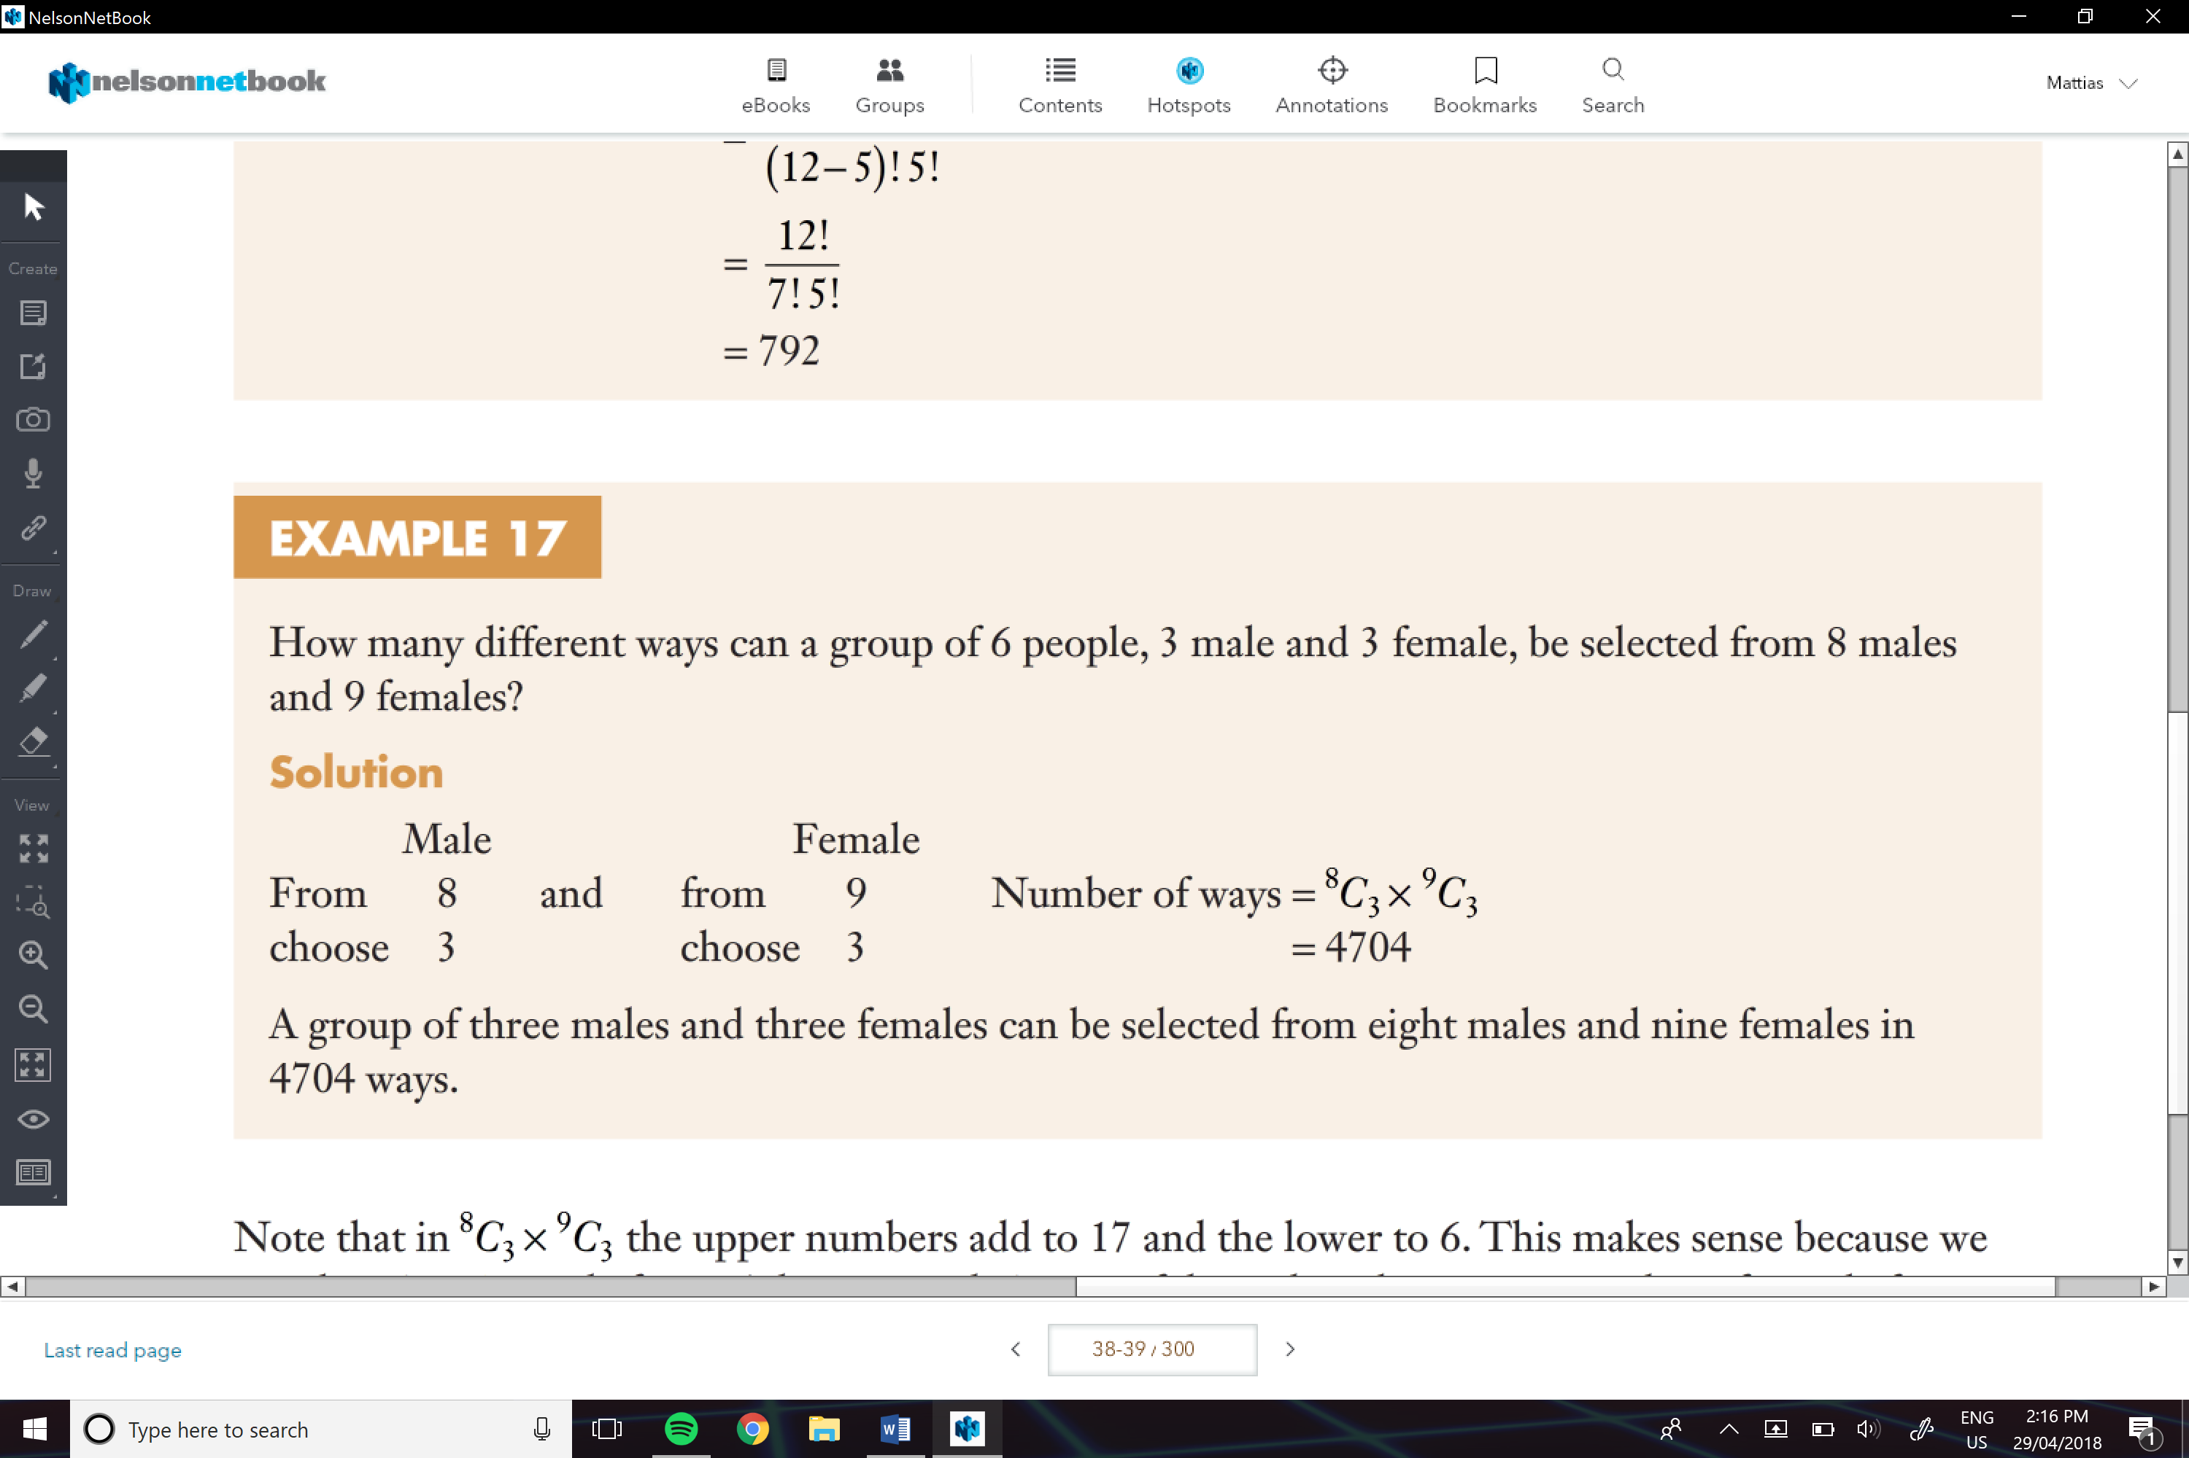

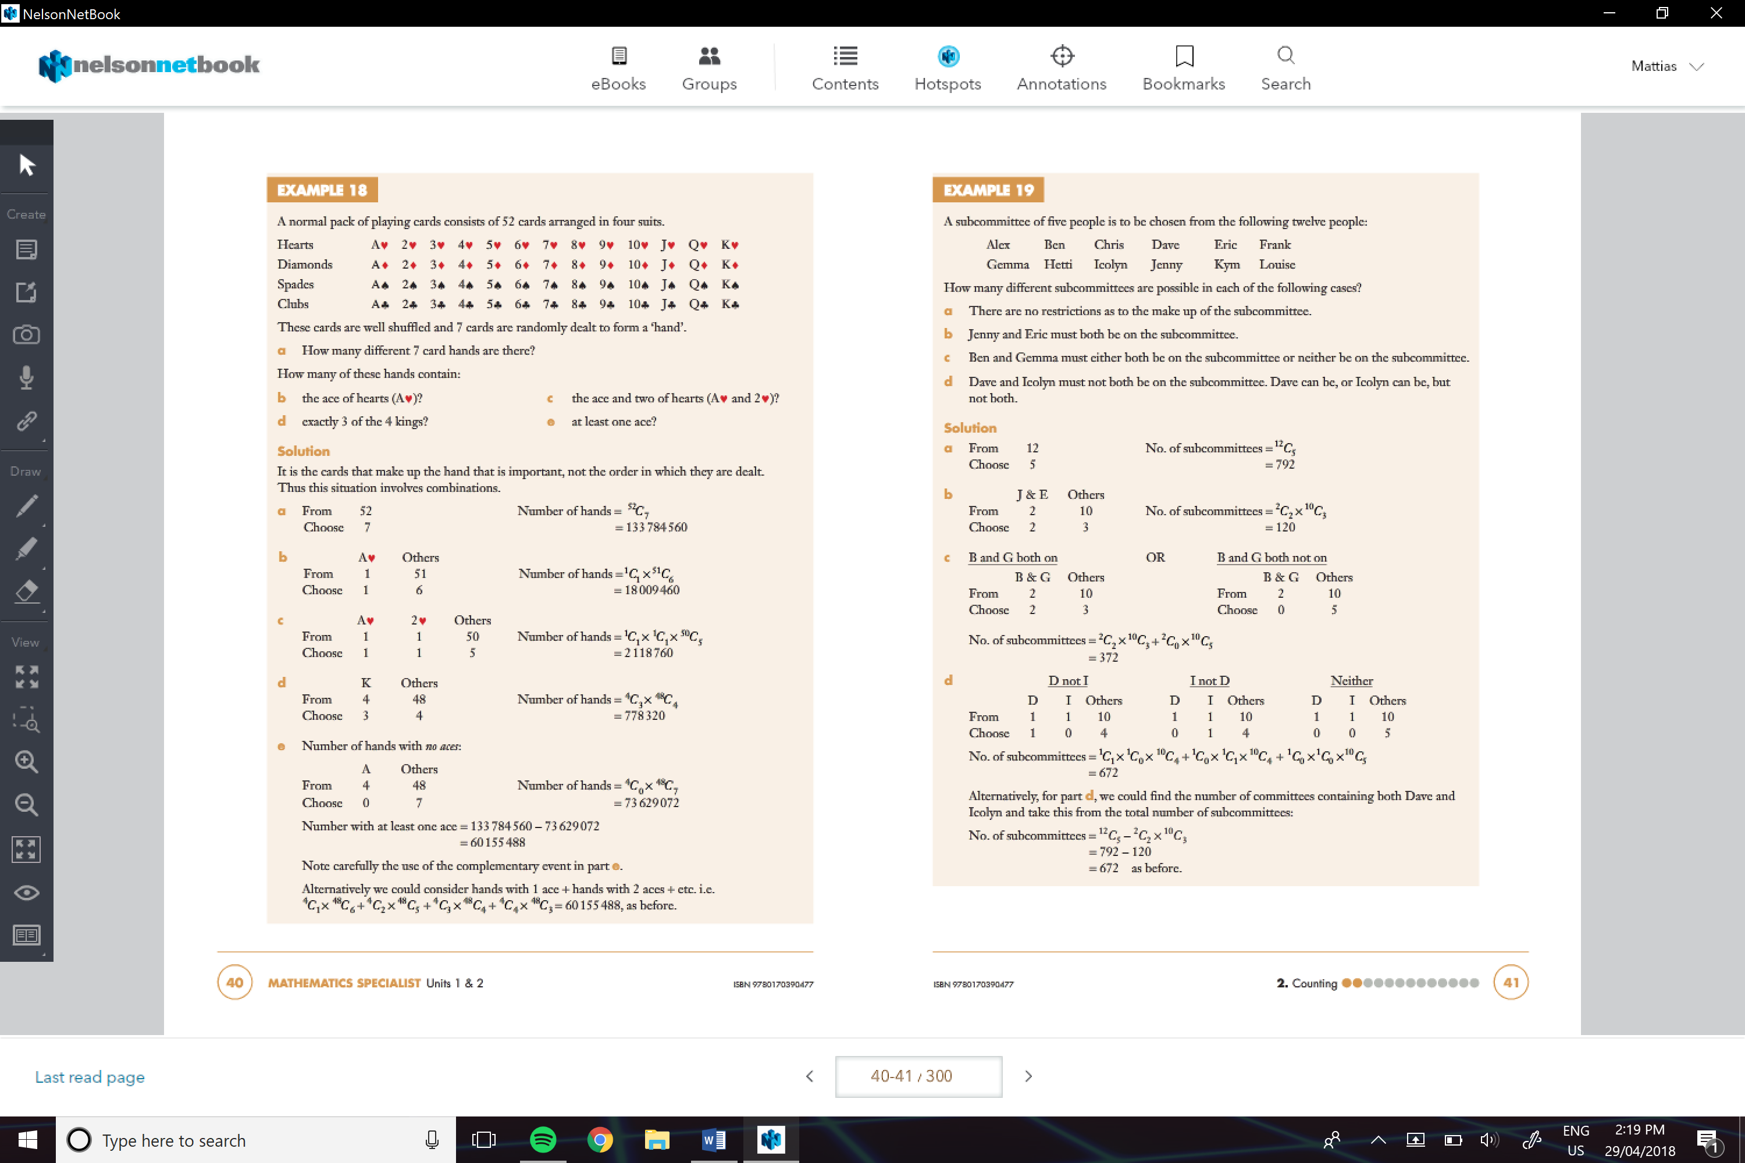

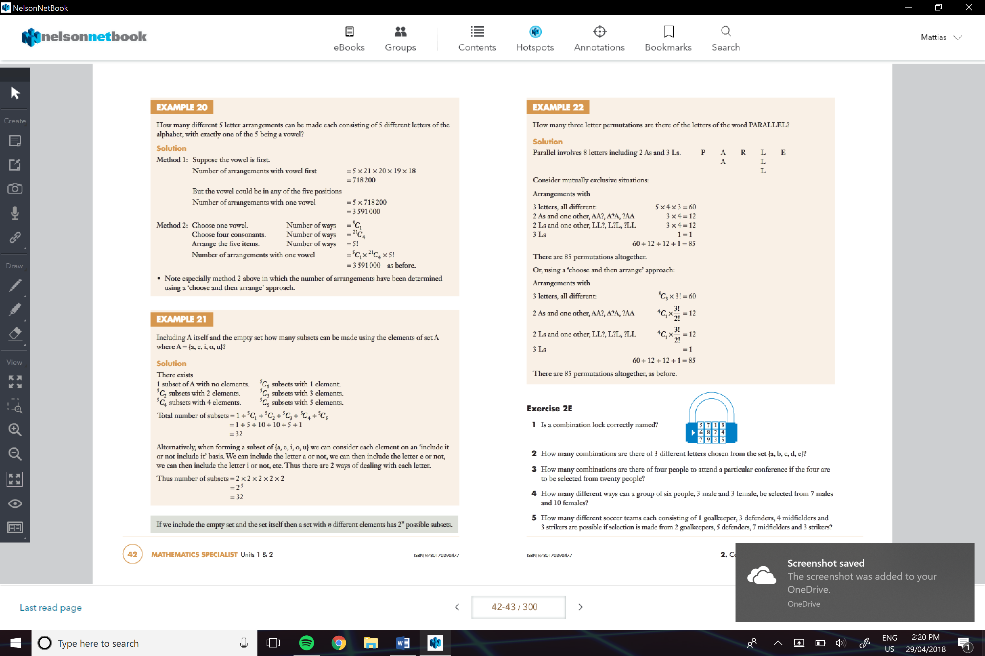



** One With Subsets

